The ‘More-Principle’
II Kings 6:8-22

After reading this story, what stood out to you? (make a list of all that the group mentions)

What are some of the things people run to when facing overwhelming odds in life?
- Where have or do you run to? (Share positive or negative)
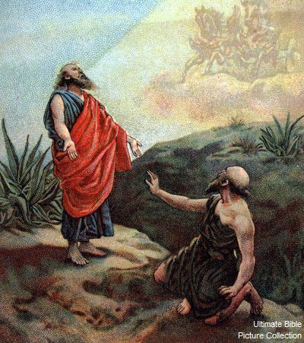
Why do you think Christians may react the way the servant reacted before the Lord opened his eyes?

Can you share an incident when the Lord opened your eyes to His presence in dark circumstances?
(focusing on God’s attributes)

Share your thoughts or experiences around the reality of supernatural evil.

Do you agree that people in general are not mindful of real evil?
- Why would Christians be oblivious to the work of evil forces in their lives or circumstances? (focus discussion on Eph 5:11 & I Pet 5:8-9)

The MORE-principle is focused on Scripture.
Spend time going through the following Scriptures grounding yourself in the Word of God.
How do you see the ‘More-principle’ displayed in the following verses?

The evil one is disarmed.
Col 1:13; Luke 11:14-28 (share a conversation on the context of this Scripture)
Your Victory through the authority of Christ
James 4:7-8; Col 2:13-17

